Template – Transcript Request Form
The template named “Template – Transcript Request Form” is applicable to Anthology Student.

Purpose and Outcome
This template provides a form sequence and supporting workflow for a transcript request to be submitted by a student. The sequence requires the following:
- A complete Student record must exist in the Anthology Student database.
- The student must have a Portal login to log into this authenticated sequence.
- The student must have a credit card to pay the fees associated with the transcript request.
The Forms Builder must support credit card payments using the PayPal or ACI payment gateways.
Upon completion of the sequence:
- A transcript is sent to the student, to another institution, or to a company.
- The transcript request is added to the student record.
- The transcript charge and payment are posted to the student’s ledger card.

The template simplifies a complete student self-service transcript request process as detailed in the Transcript Request Form README STEP 2 document.

Prerequisites
The template was built in Forms Builder using the applications listed below. The template is forward compatible with later versions of the listed applications.
Application | Compatibility Version
Forms Builder Designer and Renderer | Compatibility Matrix
Web Client for Anthology Student
Workflow Composer
Packages installed from Package Manager in Workflow Composer | Activities and Contracts (V2)  Contracts (V1)  Forms Builder Contracts  Note: Ensure that the Forms Builder Contracts package used in Workflow Composer is aligned with the version used in the Forms Builder. Additionally, confirm that both Activities and Contracts (V1) and Activities and Contracts (V2) packages in Workflow Composer match the versions used in the Student Web Client to avoid compatibility issues.  It depends on which product is being used, for example:  For CRM:  Activities And Contracts (CRM)  Forms Builder Contracts
Workflow Tracking Database | N/A
Staff STS | 3.3.x

Step 1: Download and Import the Template
- Download the template file (xml) to your environment (local drive or network location).
- Log into Forms Builder Designer.
- Click the Export/Import tile.
- Select the Import tab.
- Click Select exported file and navigate to the downloaded template file (xml).
- Click Import.
Note: Import may fail if same files name is already available in environment or overwrite option.
- Export/Import

The following forms will be imported:
- Transcript Request Form Step 1
- Transcript Request Form Me
- Transcript Request Form Payment
- Transcript Request Form Institution
- Transcript Request Form Company
- End State - Transcript Request Form

Step 2: In Form Designer…
- From the Forms slide out, select the Transcript Request Form Step 1.
- Customize the form for your environment. Modify properties on current fields to make them required, etc., or add/remove fields on form.
Make sure you edit the text in the Labels and HTML controls as applicable for your institution.
- Fields and Components
- Save the form.
- Repeat steps 1-3 for the following forms:

End State – Transcript Request Form

Transcript Request Form Company

Transcript Request Form Institution

Transcript Request Form Me

Transcript Request Form Payment
- Navigate to the Settings workspace in Forms Builder and check the Payment settings.
The imported sequence uses the VerifyCardPayment activity to process payments using the ACI or PayPal payment gateways. The activity does not support IATS payments. Ensure that your ACI or PayPal settings in Forms Builder are correct and complete.

Step 3: In Sequence Designer…
- Select the Transcript Request Form Sequence.
The sequence contains the following forms in the following order:

Transcript request Form Step 1

Transcript Request Form Me

Transcript Request Form Institution

Transcript Request Form Company

Transcript Request Form Payment
The End State – Transcript Request Form is selected as the End State Forms for the sequence.
- Click Save As to create a copy of the sequence/workflow and customize the copy for your use. This way you can always refer to the original sequence/workflow you downloaded.
- Optional - Add a custom style (theme) associated with your campus.
- Themes
- Select your sequence in the Sequences pane.
- In the Properties Pane:
  - Ensure that the Authentication Product is Student.
- Select the End State Form named “End State – Transcript Request Form”.
- Save the sequence.
- Open the associated sequence workflow.
Depending on your environment, to open Workflow Composer either click Open Workflow in Sequence Designer or launch of a local installation of Workflow Composer.
- Opening Workflows for Sequences

Step 4: In Workflow Composer…
- Double-click the first form/state of the workflow named “Transcript” and locate the Assign activity named “Assign Transcript Amount”.
Update the hard-coded depositEntity.Amount value of 7.00d as appropriate for your environment.
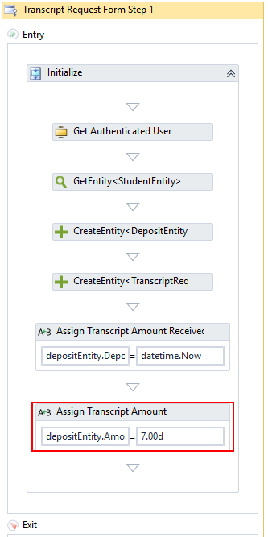

- Double-click the Continue transition towards the end of the workflow and locate the CreateCharge activity.
Select a Charge Code as appropriate for your environment.
Update the hard-coded Amount value of 7.00d as appropriate.
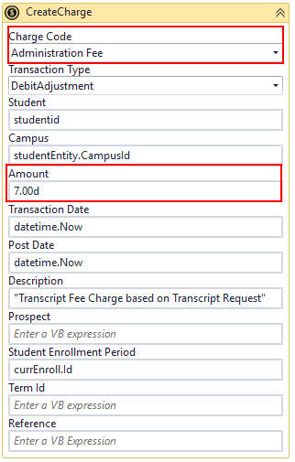
- Create Charge activity

- If Cash Drawer Sessions are used at your campus, locate the Send to Student Accounts sequence further down in the Continue transition and add assignments for the following values:
- CashDrawerId
- CashDrawerSessionId
- CashierId

Step 5: In Forms Renderer and Anthology Student…
Select your sequence and try it out!
- Sequence List
- Find your Transcript Request Form Sequence and copy the URL to the clipboard.
- Log in to Portal as a student and complete the form sequence.
- In Anthology Student:
- Verify that the transcript request was added for the student.
- Verify that the student's transcript charge and payment posted to the ledger.

Step 6: Lastly…
Once your updated sequence has been tested successfully, it is recommended that you disable the workflow for the original Template version.
- In Workflow Composer, in the Server section of the ribbon, click Open.
- Find the workflow named “Transcript Request Form Sequence”.
- Clear the Enabled check box and click Save.

